**CP Club 365 Days Challenge**

**Programming language – C++**

**Problem Statement**

<https://www.codechef.com/DSAPREP_01/problems/PIXDAM>

**Your Code**:

// 0x79Day of 0x365Days challenge

// VEDANT BHARAD

// 4-1-2023

#include <bits/stdc++.h>

using namespace std;

int main()

{

    int t;

    cin>>t;

    while(t--)

    {

        long h,w,x,y,k;

        cin>>h>>w>>x>>y>>k;

        long temp;

        temp = ((w-x)*(w-x))+((h-y)*(h-y));

        if(sqrt(temp)<k)

            cout<<1<<endl;

        else

            cout<<0<<endl;

    }

    return 0;

}

**Output (Screen Shot)**:

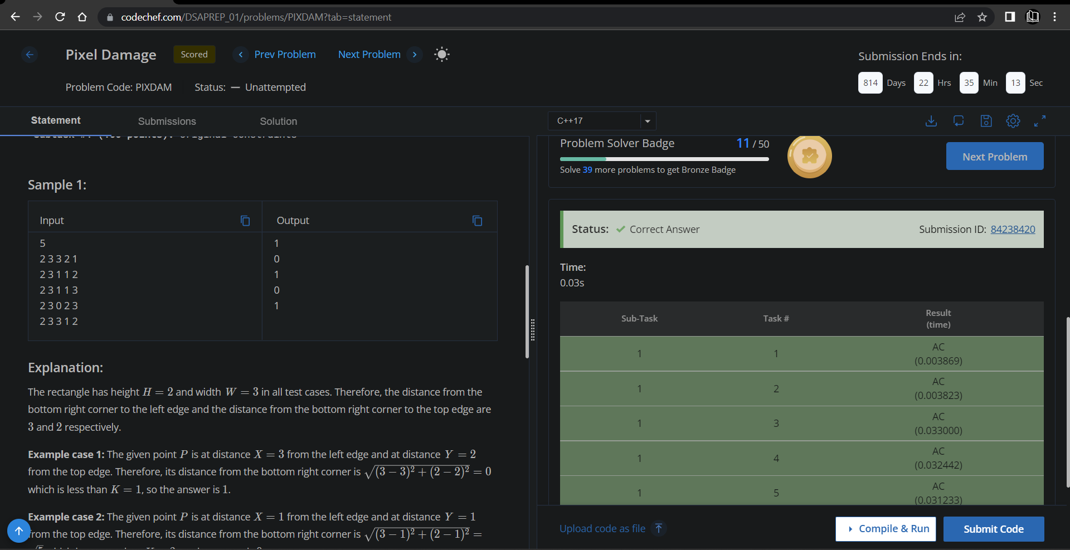

**Understanding about problem:**

* In this task there are h,w,x,y,k int as a input.
* In this task output will be in 0 or 1 which depends on one equation which is ((w-x)*(w-x))+((h-y)*(h-y)) and its root if that answer is less then k then return 1 else 0.

Note: If you can't understand the problem, feel free to contact us and we'll help you. Please don't copy and paste from anywhere.

ALL THE BEST

Team CP Club